Andy Scott  
CIS 2818  
Prof John Baugh  
11 December 2023

Andy’s Simple Sketchpad App

This app is designed for note taking on-the-go. The app opens immediately to the main activity where users can make a title and description for their notes, ideas, lyrics, chapters of a book, or whatever they feel they need to write down and save for later viewing. Once users are finished writing their note, they can save it and use the “Show Notes” button to view notes they have written. The program will notify you when a note has been saved with the “Save” button.

MainActivity:  
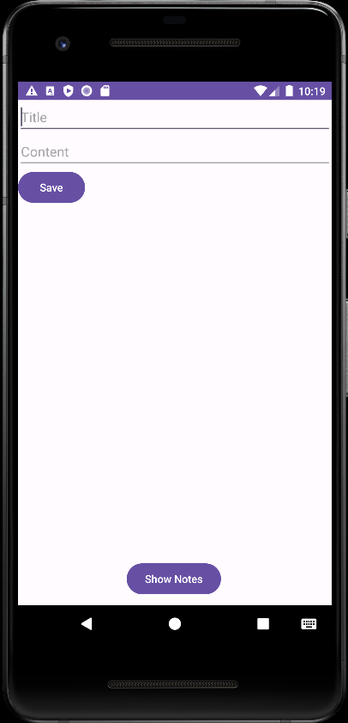 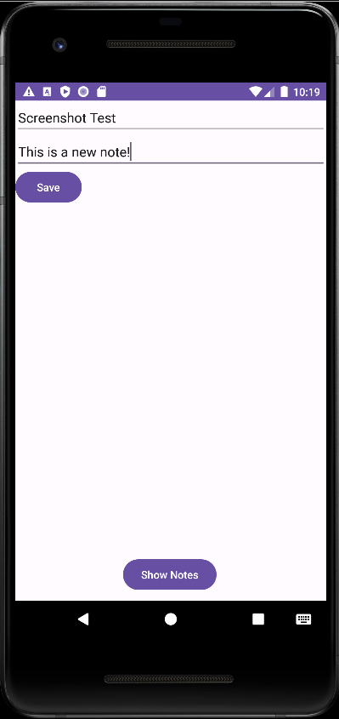  
  
Here we see editText fields for the Title of your note and the content for your note. Underneath that, we see the save button. At the bottom, the “Show Notes” button will take you to your dashboard, also known as the Notes Activity.

Saving a note/Viewing a Note:  
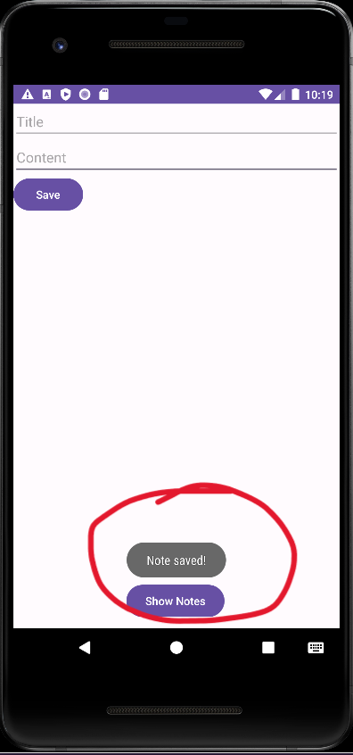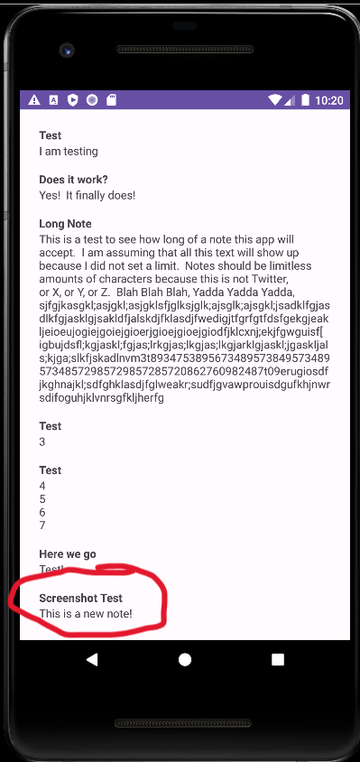  
  
Here we see the Toast notification that our note has been saved. Now, to view the note we press “Show Notes” to take you to the Notes activity. The notes activity contains a chronological list of your notes for viewing. Just like a real sketchpad, what you write is in the order that you wrote it, page by page.